

|  |  |
| --- | --- |
|  | Lab 3: Blob Storage, Website Hosting & cloud witness. |
|  |  |
|  | Akshar Panchani ID- 202101522  IT457 Cloud Computing  2/18/24 |

1. Complete the following tutorial about pictures and blob storage:

Environment Variables: -

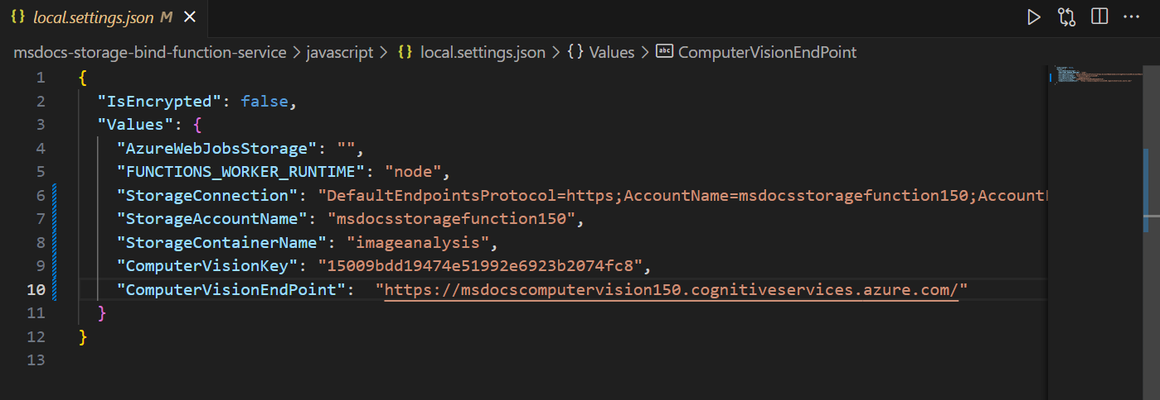

Function App Published: -

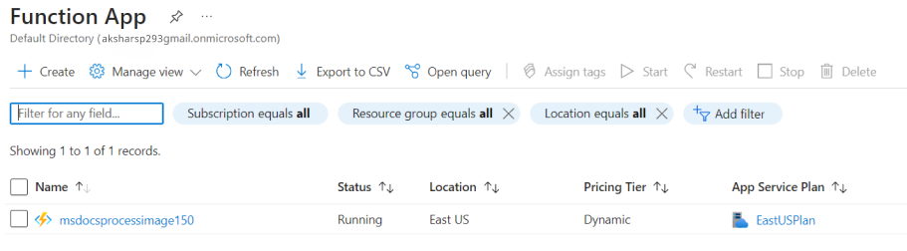

Container and its contents: -

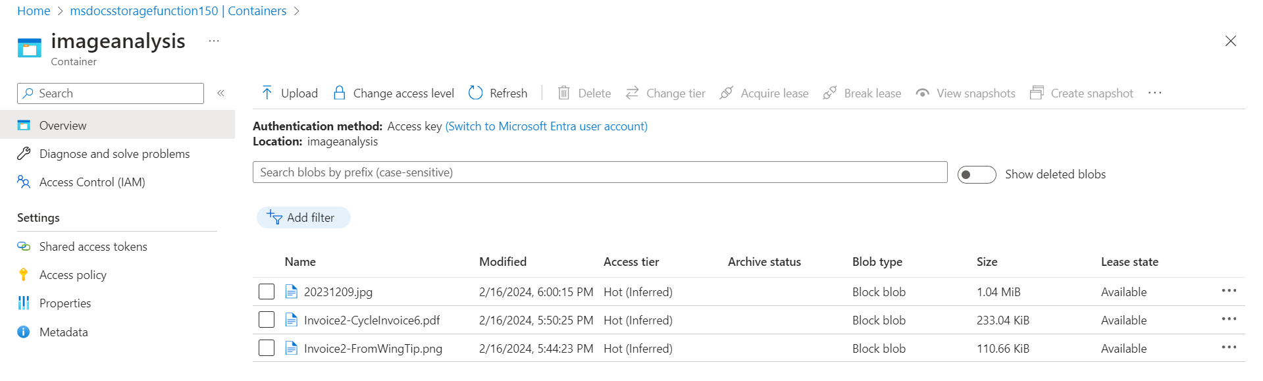

Overview: -

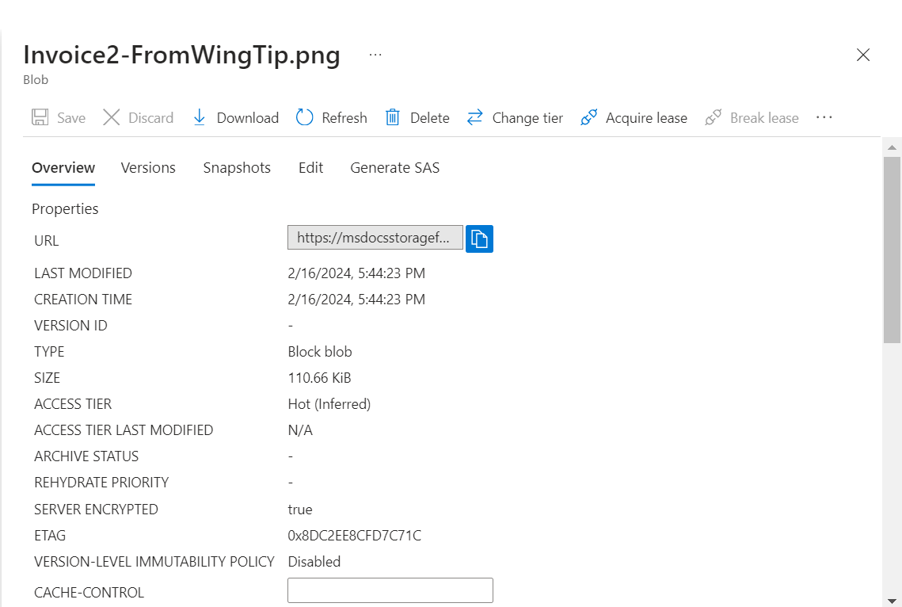

Outputs of contents stored in blob storage: -

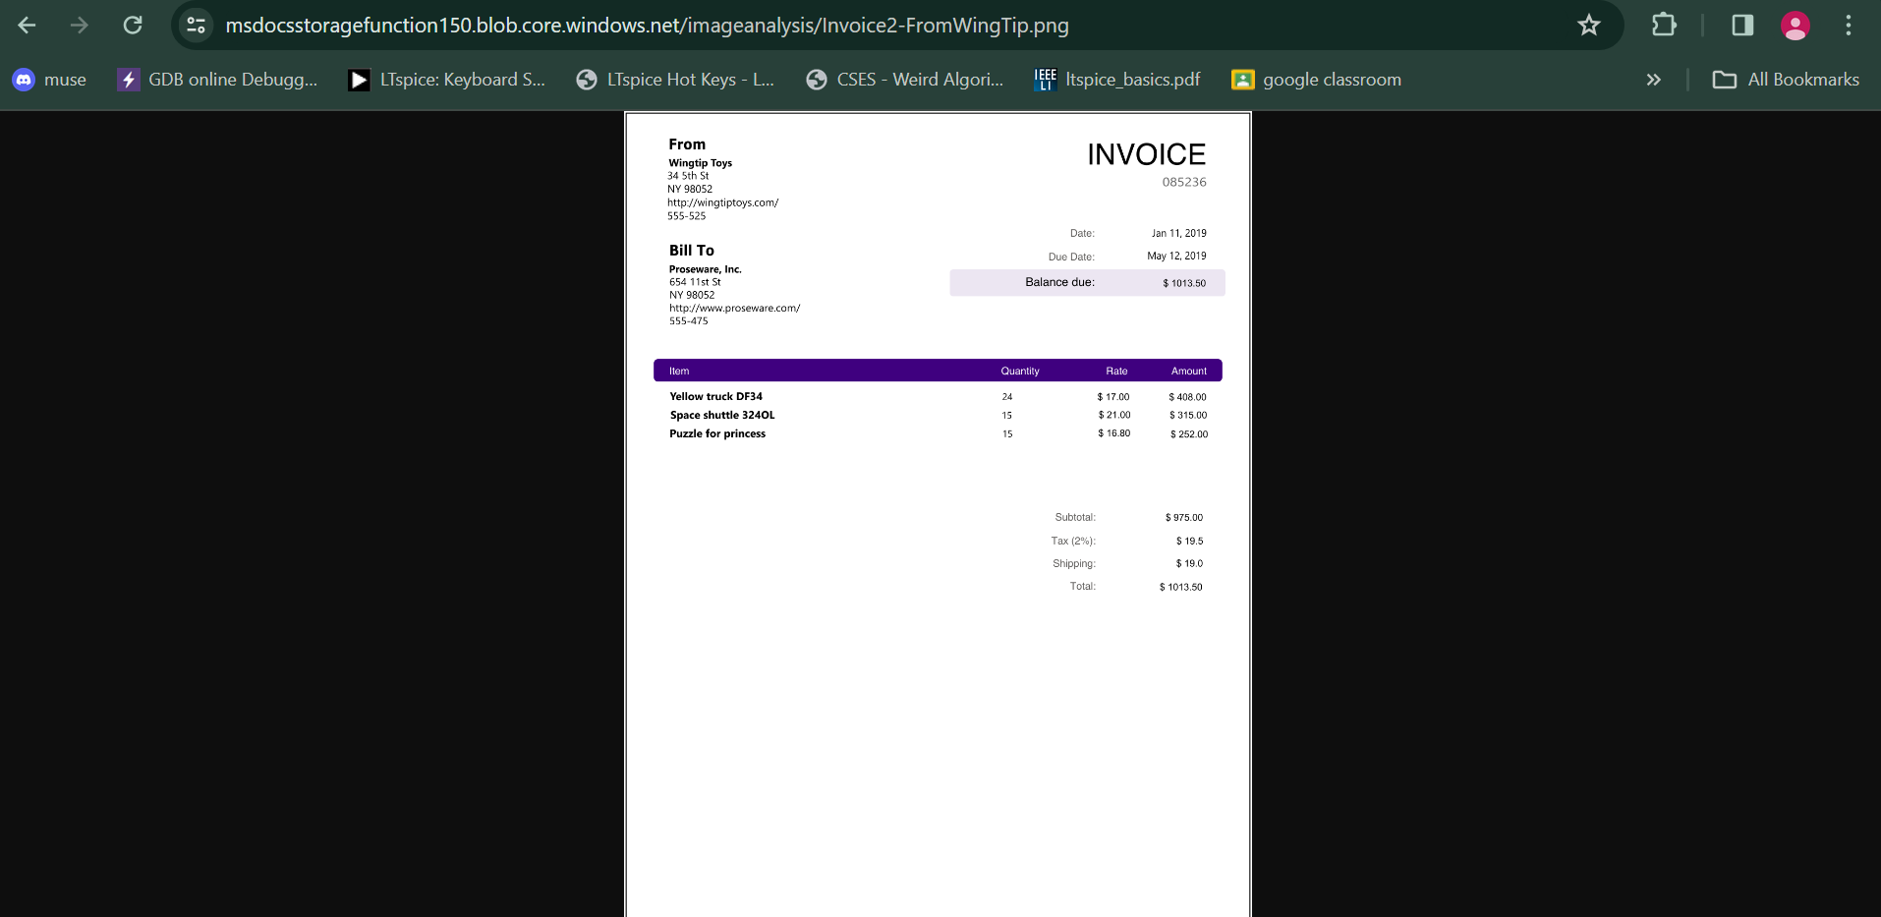

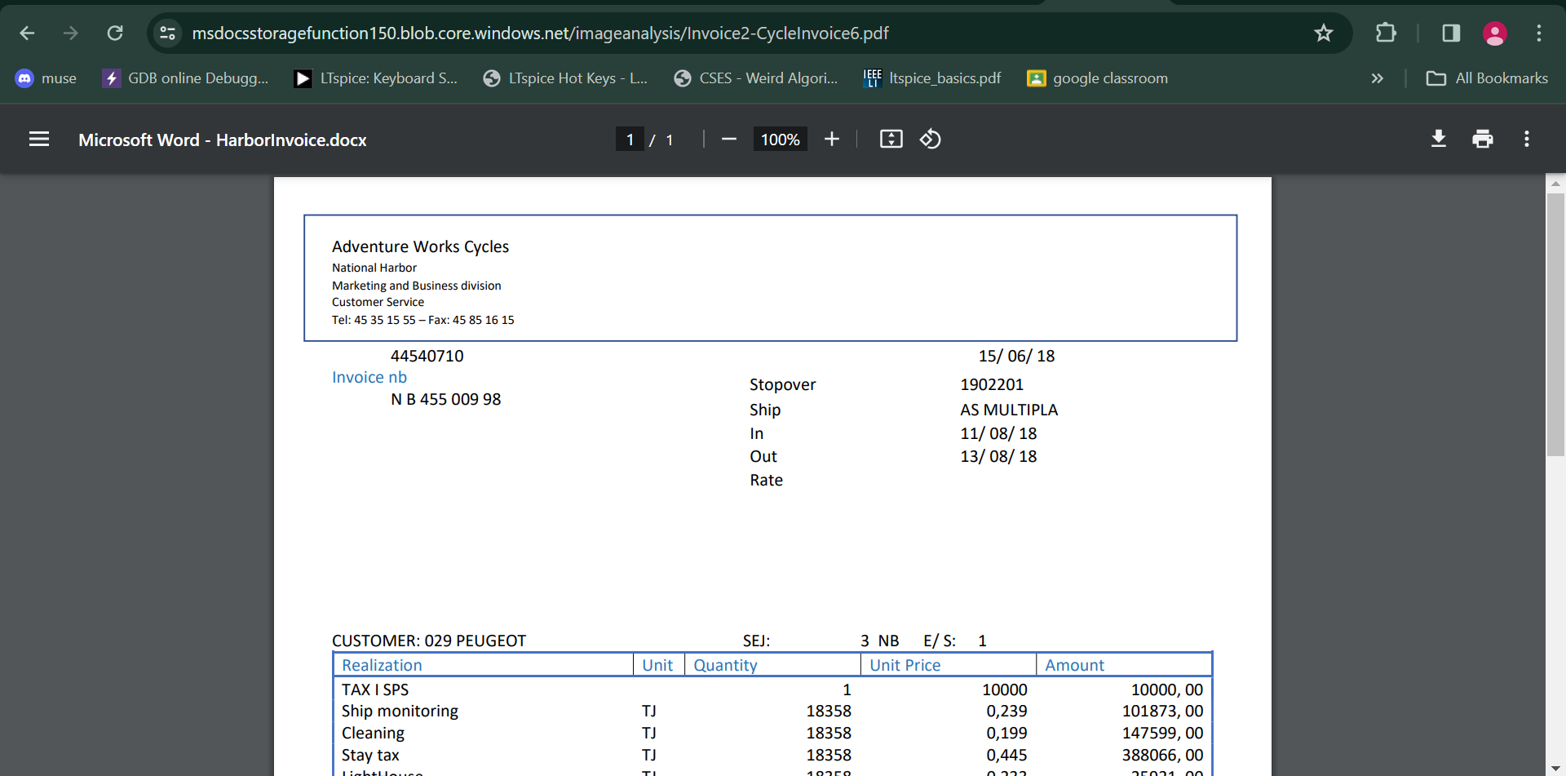

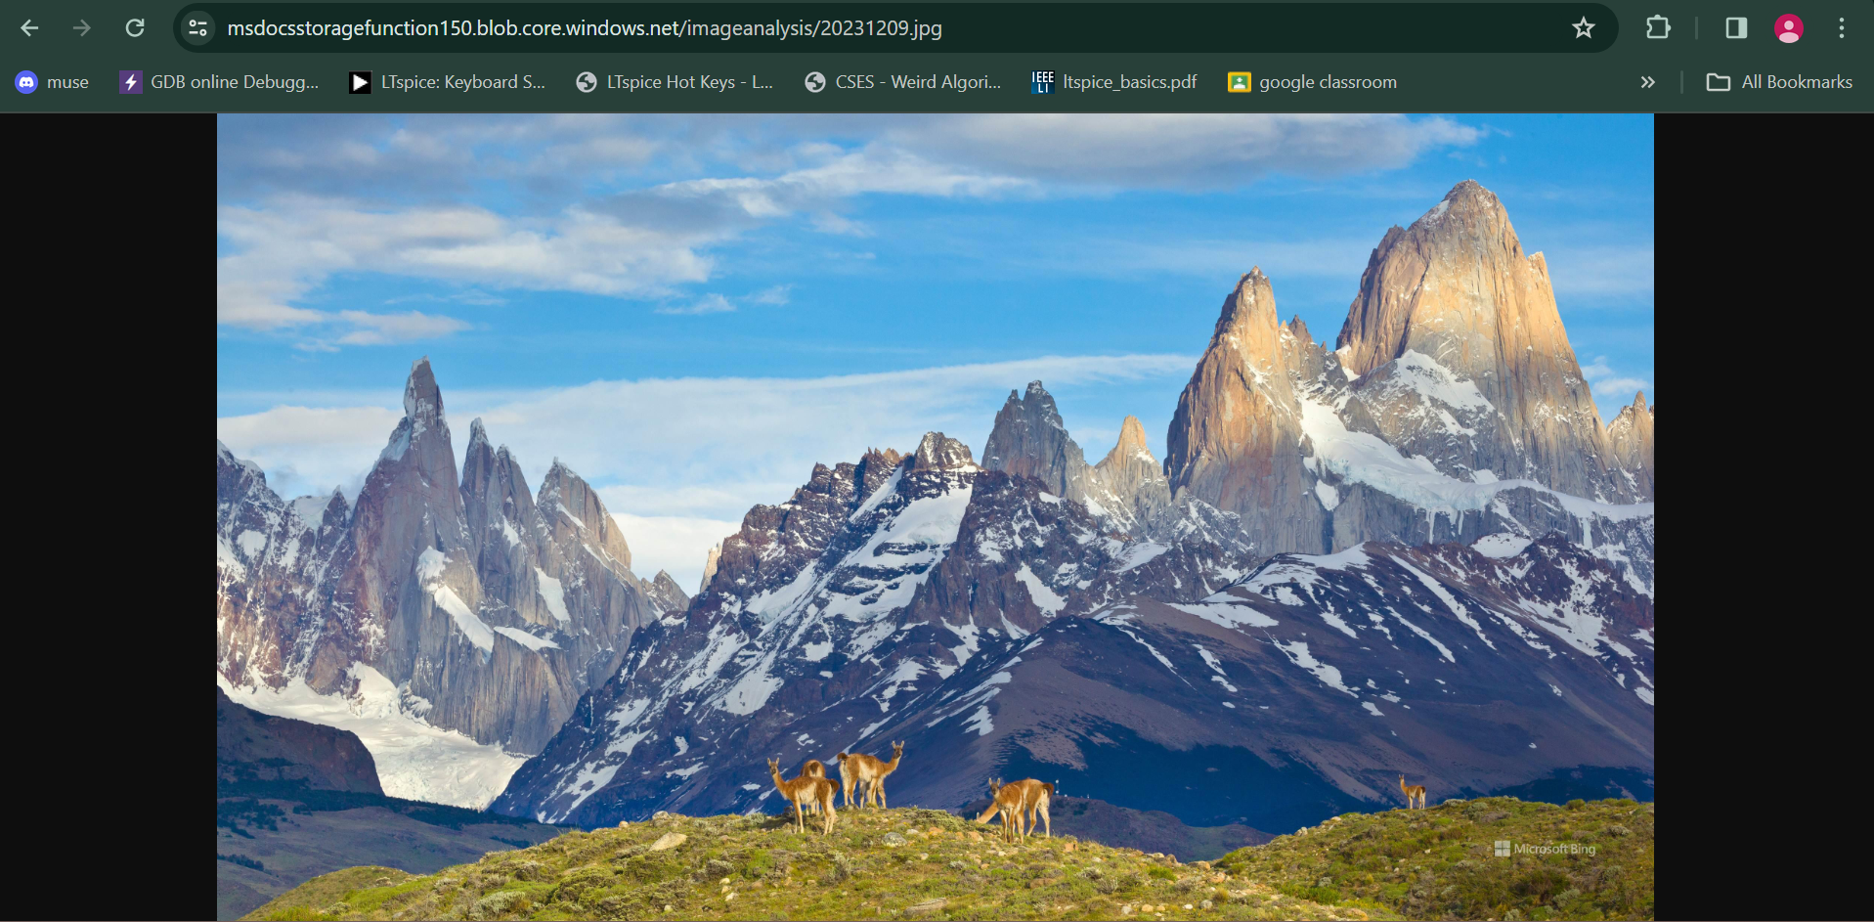

2. Complete the following tutorial about static content website hosting:

Container:

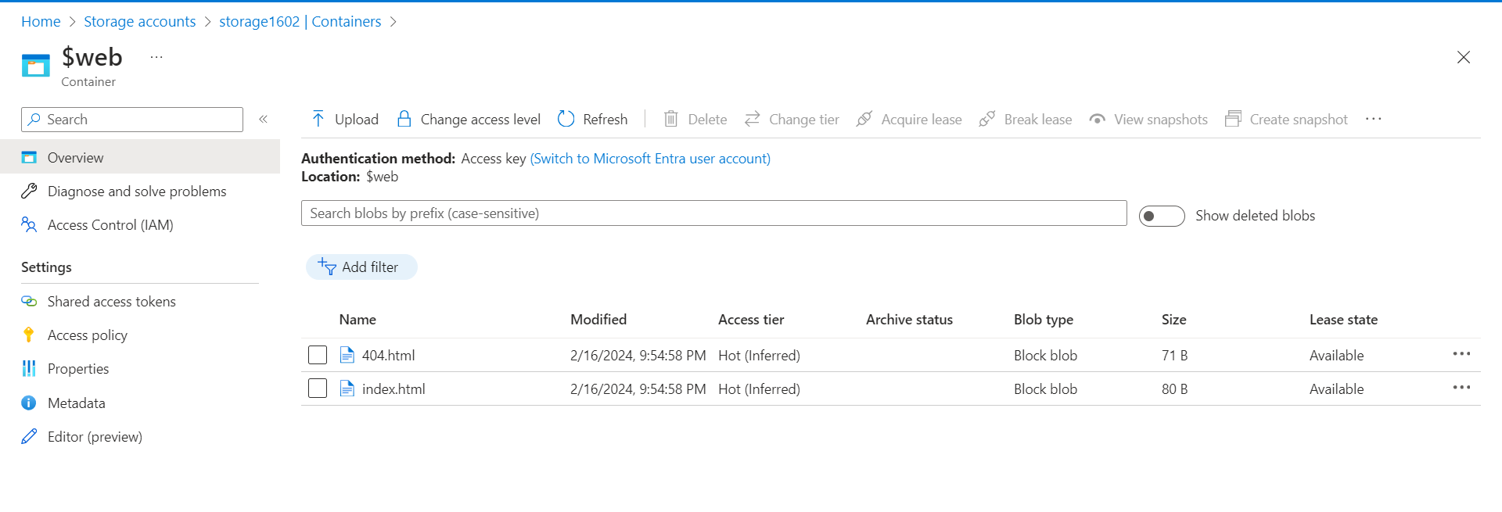

Codes:

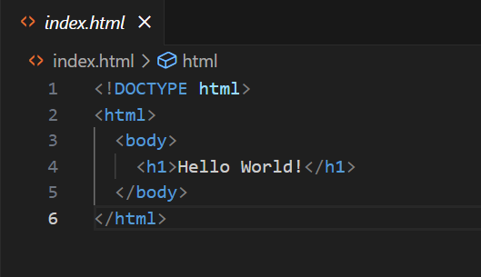 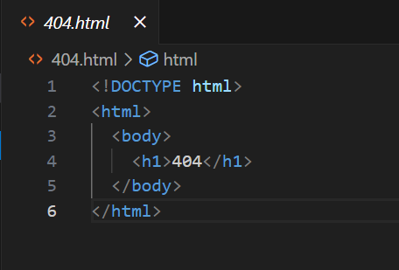

Output:

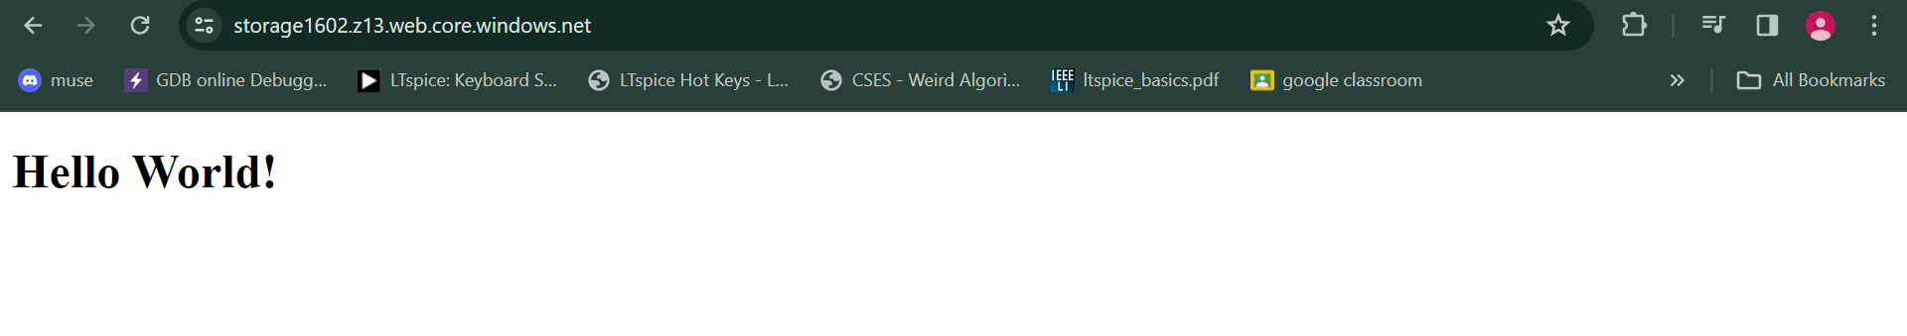

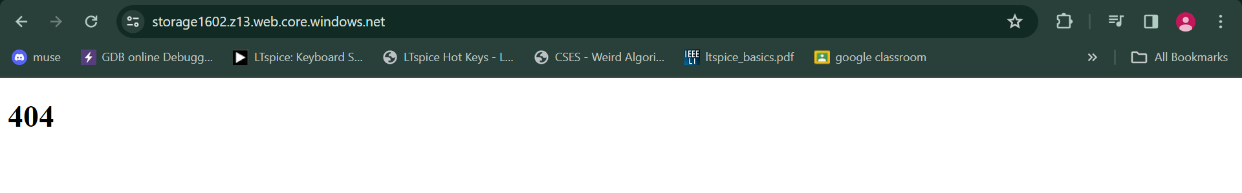

3. Complete following tutorial for designing application with high availability

Initially: -

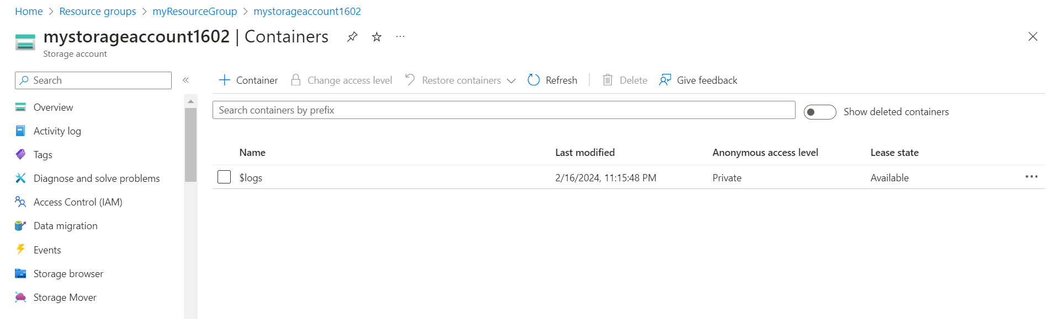

Result after running code from V-12 in Visual studio: -

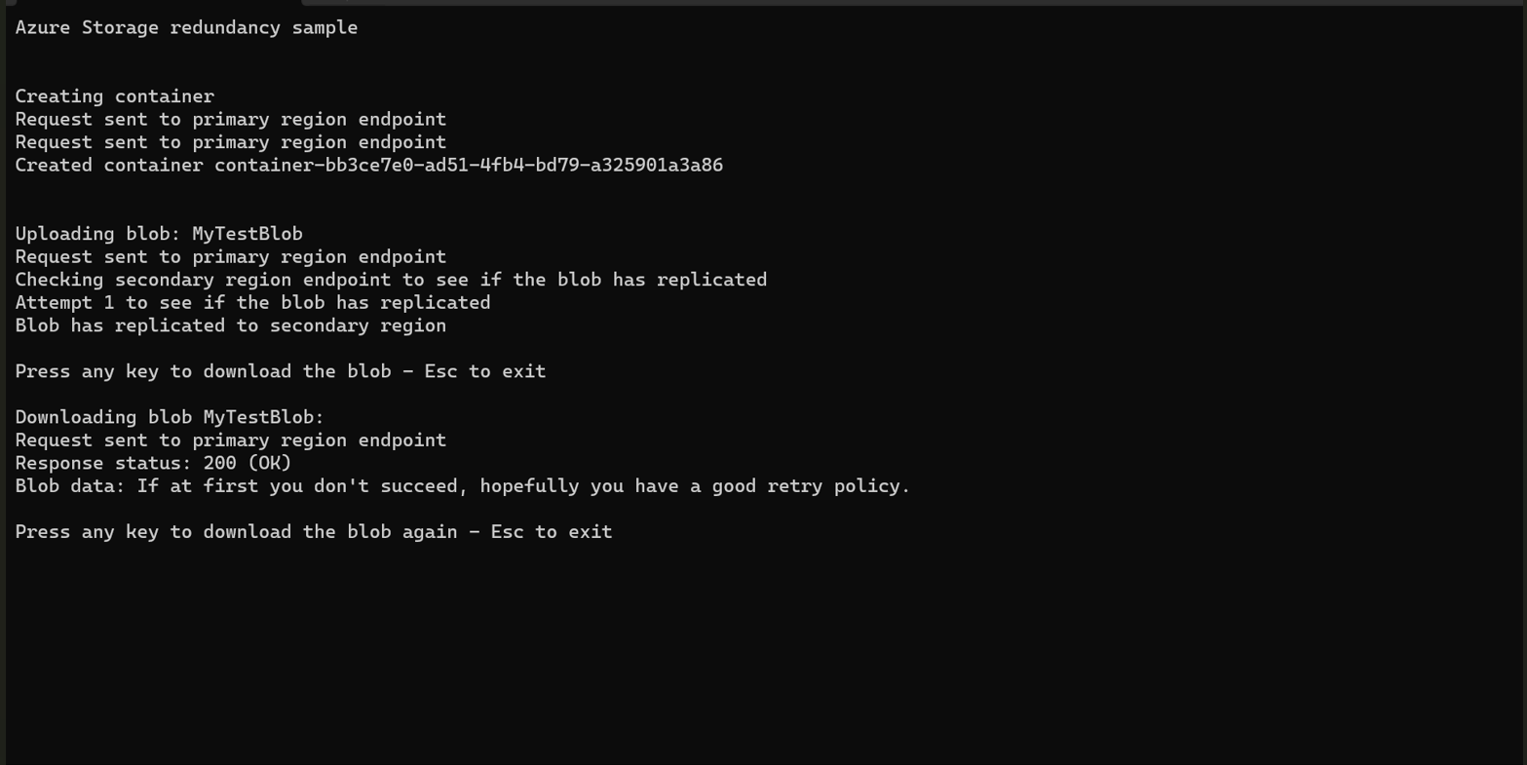

Blob spread to a secondary location, resulting in increased availability.

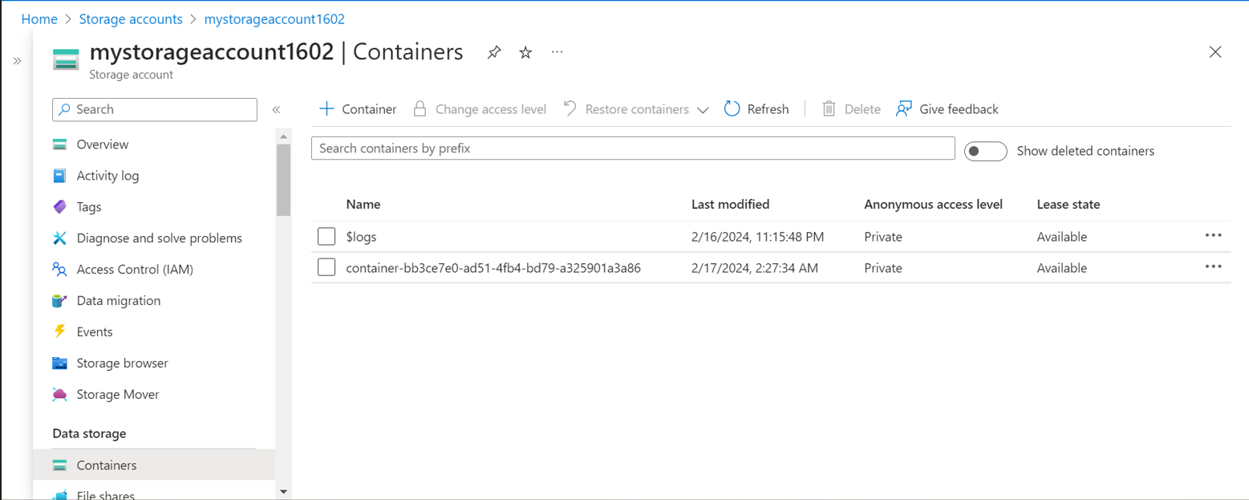

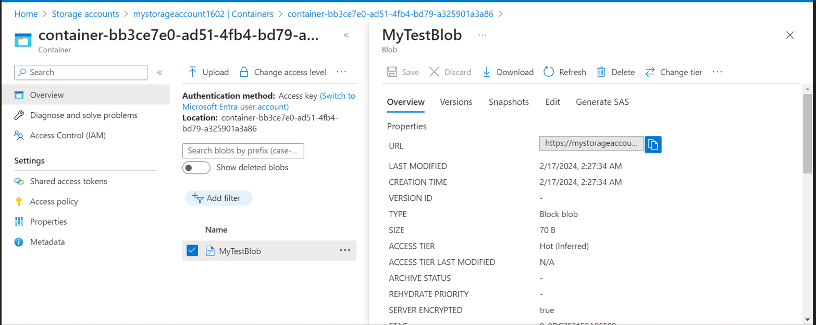

4. Complete the tutorial to add role assignment to blobs:

Two text files with distinct tags in blob storage: -

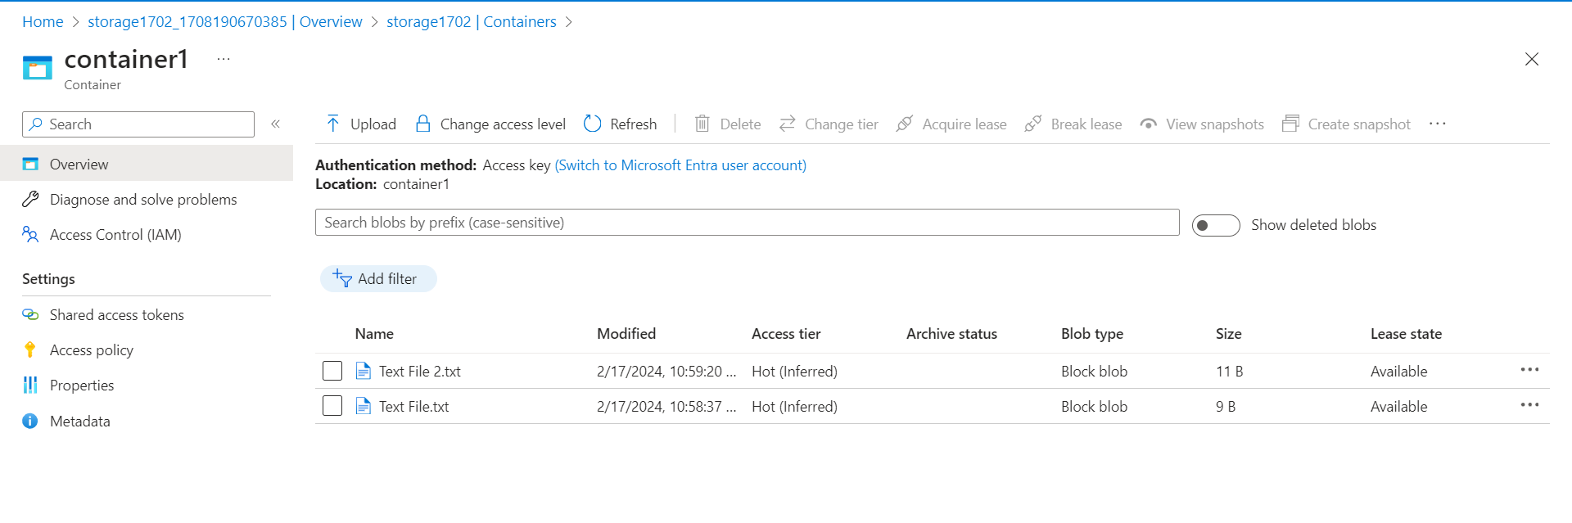

Assigning Role of storage blob data reader: -

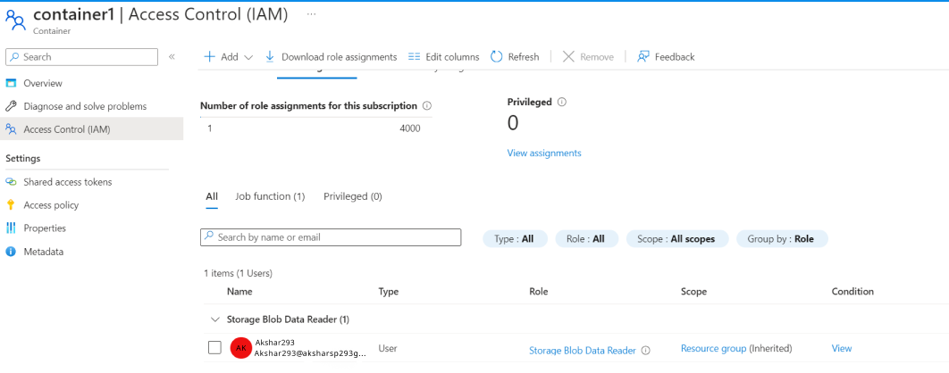

Result:

When a user is assigned a storage blob read role, they may access files with that tag; files with other tags cannot be accessed.

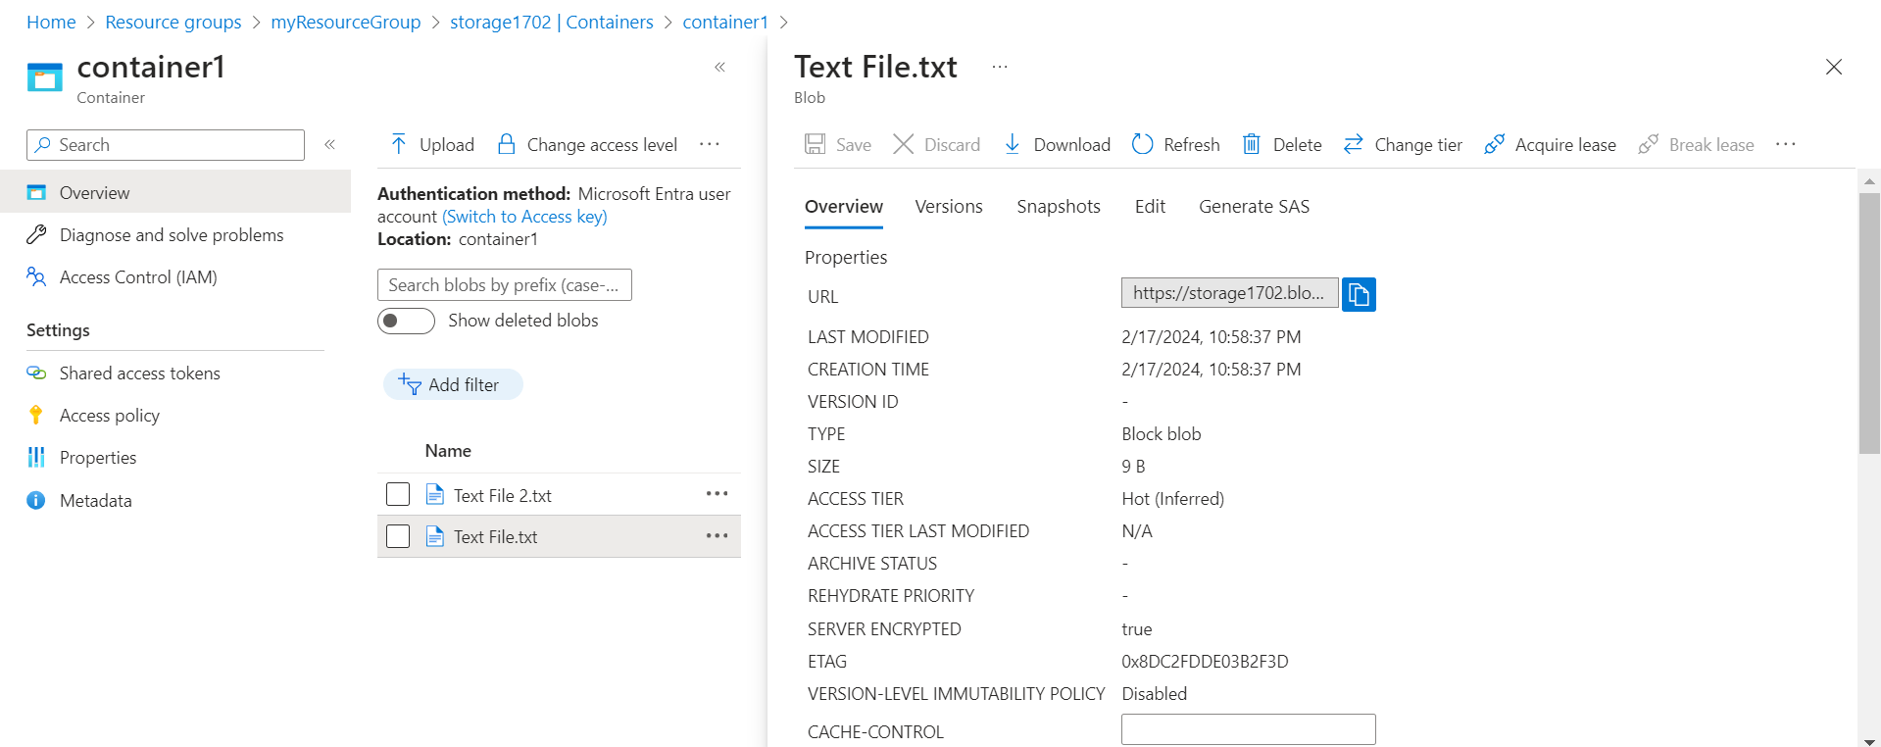

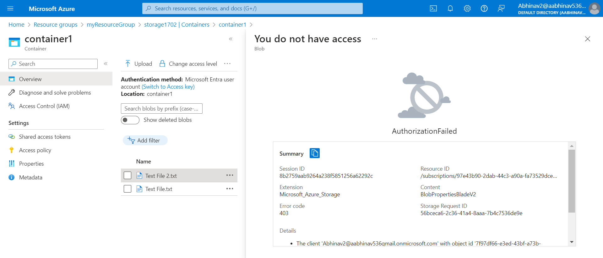

5. Complete the tutorial to deploy cloud witness: -

Access Keys:

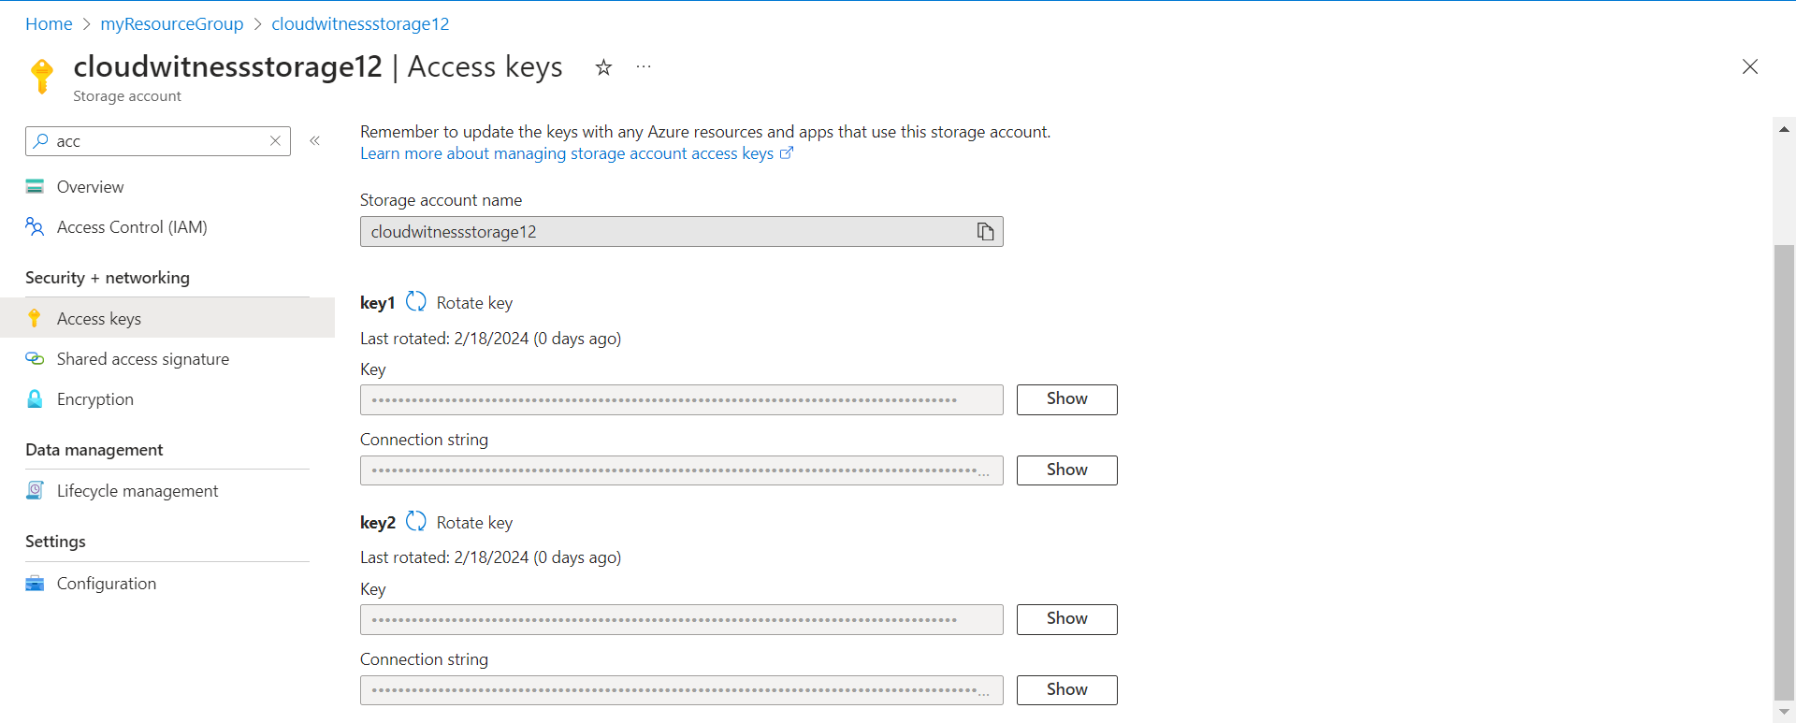

VM:

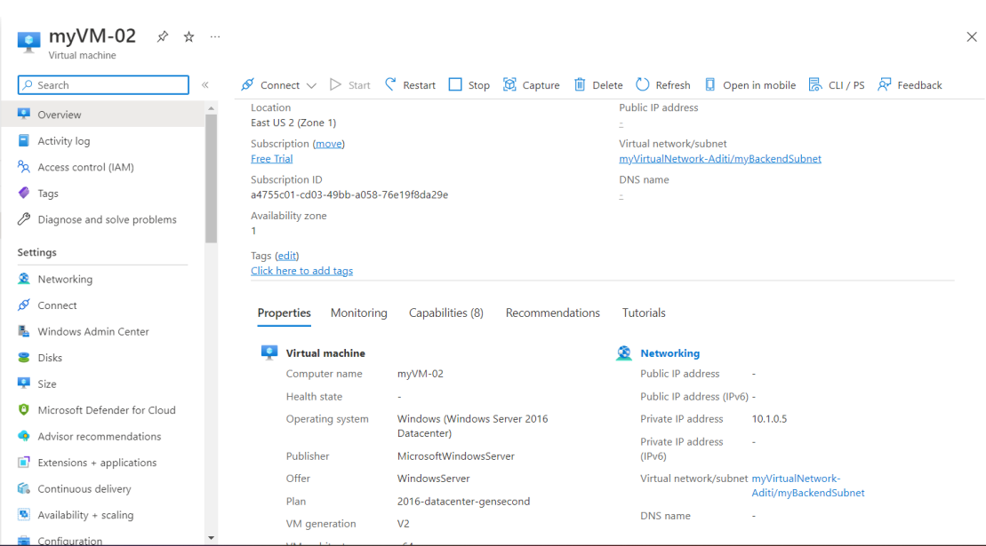

Cloud Witness:

